ComicCraft – AI Comic Story Creator powered by Gemini & Stable Diffusion
Project Design Phase-II
Data Flow Diagram & User Stories
Date | 28/09/2026
Team ID | SWTID-2026-1512
Project Name | ComicCraft

Team Leader: LAKSHMIPRIYA M | Team Members: KAVIYA K, KIRTHANA, KOWSALYA M
Data Flow Diagram:
A Data Flow Diagram (DFD) is a traditional visual representation of the information flows within a system. It shows how data enters and leaves the system, what changes the information, and where data is stored. The diagram below traces a request from the user's story idea through validation, the two Gemini stages, image generation, layout building, and PDF export.
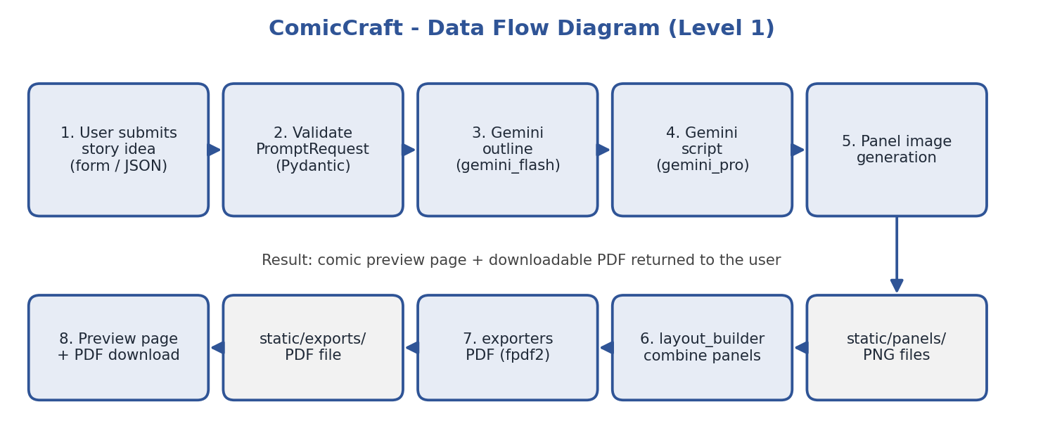
Figure 1: ComicCraft data flow diagram
User Stories
Use the below template to list all the user stories for the product.
User Type | User Story Number | User Story / Task | Acceptance Criteria | Priority | Release
Creator | USN-1 | As a user, I can enter a story idea, character name, and setting in a web form | Form accepts the inputs and submits them to the server | High | Sprint-1
Creator | USN-2 | As a user, I can choose tone, art style, and 3–5 panels | Selected options are used when the comic is generated | Medium | Sprint-1
Creator | USN-3 | As a user, I receive an AI-generated comic outline | Outline contains exactly the requested number of panels | High | Sprint-2
Creator | USN-4 | As a user, I get a caption, narration, and dialogue for every panel | Each panel shows scene, caption, narration, and dialogue | High | Sprint-2
Creator | USN-5 | As a user, I get an image for every panel | One image is generated and stored per panel | High | Sprint-3
Creator | USN-6 | As a user, I can preview the finished comic in the browser | Preview page displays all panels in order | High | Sprint-3
Creator | USN-7 | As a user, I can download the comic as a PDF | PDF opens and contains all panels with text | High | Sprint-3
Creator | USN-8 | As a user, I see a clear message if generation fails | Error box appears and the form keeps my entries | Medium | Sprint-4
Developer | USN-9 | As a developer, I can request a comic through a JSON API | POST /generate-comic/json returns the comic as JSON | Medium | Sprint-3

